

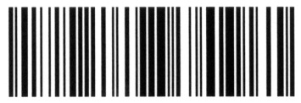

All rights reserved
Copyright 2011


USERS MANUAL

LAN BASED SALES AND INVENTORY SYSTEM USING BARCODE READER FOR GAZUTO MERCHANDISING INC.

Conceptualized by:

Rich Gerrome K. Marquez
Janine Andrea Marie S. Singian

T A B L E O F C O N T E N T S
1
Introduction…………………………………………………………......
2
Software and Hardware Requirements……………………………….
3
Installation……………………………………………………………….
4
Server Settings………………………………………………………....
5
Login Module……………………………………………………………
6
Main Module……………………………………………………………
7
Product Listing………………………………………………………….
8
Manage Suppliers…………………………………………………….
9
Suppliers Product……………………………………………………..
10
User Records………………………………………………………….
11
Users Log………………………………………………………………
12
Order & Receive……………………………………………………….
13
Stock Monitoring…………………………………………………….…
14
Physical Counting………………………………………………………
15
Critical Product(s) ……………………………………………………
16
Defective Stock………………………………………………………….
17
Ordering Kiosk………………………………………………………..
18
Cashiering…………………………………………………………….
20
Sales Receipt…………………………………………………………
21
Reports………………………………………………………………..

I N T R O D U C T I O N
The project was undertaken to provide the Gazuto Merchandising Inc. with a LAN-Based Sales and Inventory System using Barcode Reader software solution that delivers the acceptability of the system in terms of functionality, reliability, availability and maintainability.
It also helps the company on how to properly manage their computerized sales and inventory.
This manual provides an overview on how to use the computerized LAN-Based Sales and Inventory System using Barcode Reader for Gazuto Merchandising Inc.

1

The system design and capability is for exclusive use of Gazuto Merchandising Incorporated only.
Software Requirements:
- Windows XP, Vista or 7
- Microsoft Visual Studio 2008
- Microsoft SQL Server 2008
- Microsoft.NET Framework 3.5
Hardware System Requirements:
- Monitor (VGA or higher resolution monitor)
- Processor (Dual Core or higher)
- Memory at least 1GB or higher
- Disk space at least 500MB or higher
- CD-ROM (36x or higher)
- Keyboard and Mouse
- Printer
- Router or Switch
- Barcode Reader (optional)
- LAN Cable (Straight Through)

2
I N S T A L L A T I O N
- Copy and Paste the "Sales and Inventory System” to your Drive C:
- Run and open SQL Server 2008 >> SQL Server Management Studio, choose Windows Authentication and click Connect.
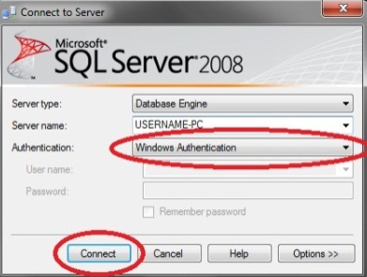

- Right click on Databases then click Attach then find the path of “SalesInv_DB.mdf”
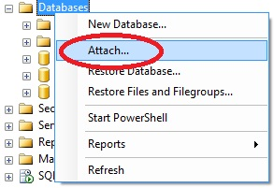

- Attach the “SalesInv_DB.mdf” Database to your SQL Server Database.
- Close SQL and run the prj_SalesInventory.exe located at Drive C:
3
SERVER SETTINGS
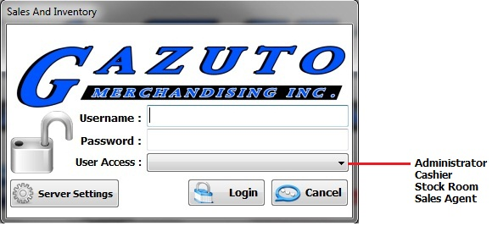
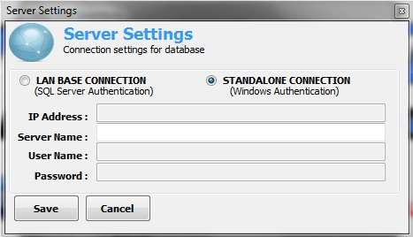
- The user will choose whether it is Stand Alone or LAN Based.
- Choose STAND ALONE CONNECTION if you are the Server and enter the Computer Name.
- Choose LAN BASE CONNECTION if you are connecting through the server. Enter the IP Address of the server, username and password of SQL for authentication.

*Default username is SA (lower case)

4
5
LOGIN MODULE

1. After you have configured the LAN settings, the user now will enter his/her Username and Password then click the dropdown button for the type of account (Administrator, Cashier, Sales Agent, and Stockroom)
2. The system will automatically close if the user fails to enter his correct username and password after three (3) tries.

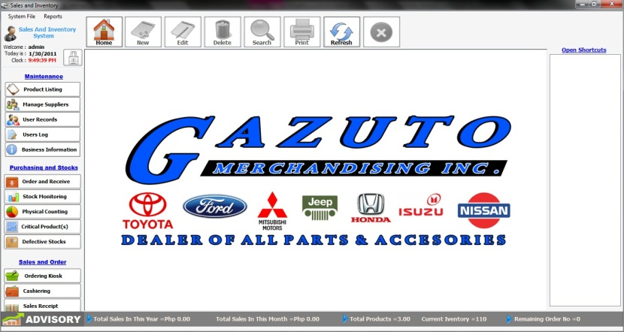
MAIN MODULE

Only the ADMINISTRATOR has a full access on the system. The admin can do all the transaction he/she wants to do.
Cashier can only access the Sales and Order.
Sales Agent can only access Product Listing and Purchasing and Stocks.
Stockroom can only access Purchasing and Stocks

Other icons will be disabled if the user is not an Administrator account.

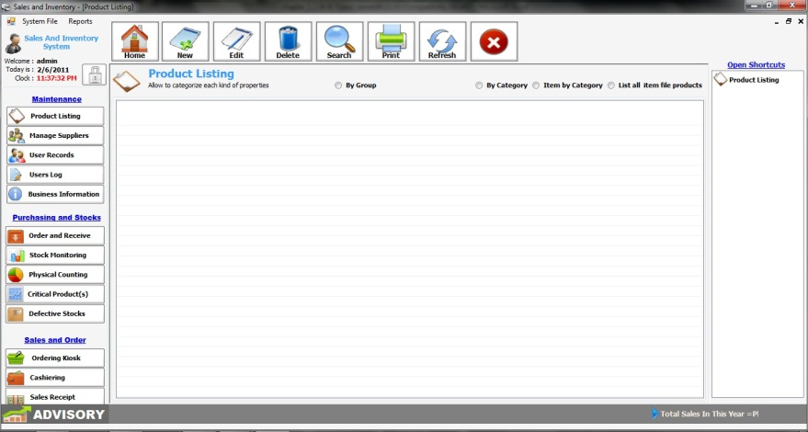
PRODUCT LISTING
By clicking  you can add and edit an item.

In adding, the user should fill out all the information needed for the item. An error message will prompt if the specific information did not filled up correctly.

In editing, the user can change the information that already exists in the item and also the barcode number.
Click delete button if you want to delete an item in the Product Listing.

6
7
MANAGE SUPPLIERS
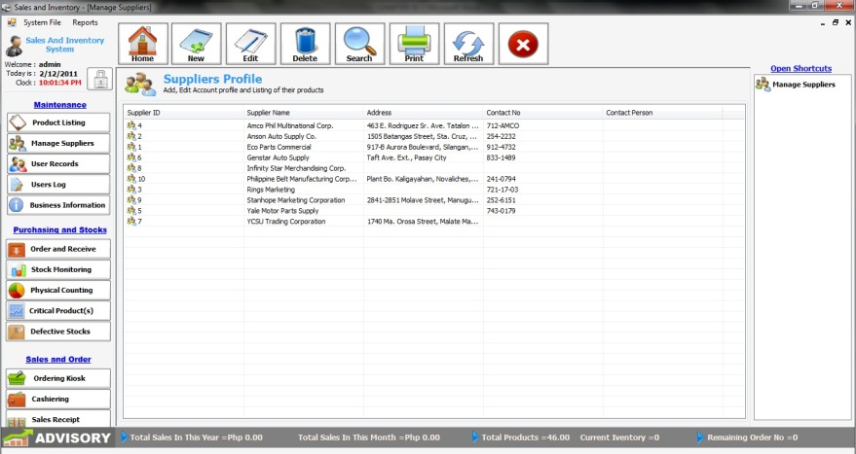
In this module, the user can add, edit and delete supplier.
By clicking the 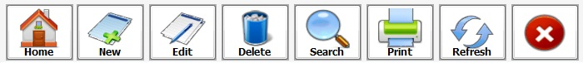 new button you can add a new supplier for tracking purposes. Just fill out the information needed for the supplier.
By clicking edit button you can edit the specific information of the supplier.
By clicking delete button you can delete a supplier from the database.
By clicking print button the system will print the suppliers list.

SUPPLIERS PRODUCTS

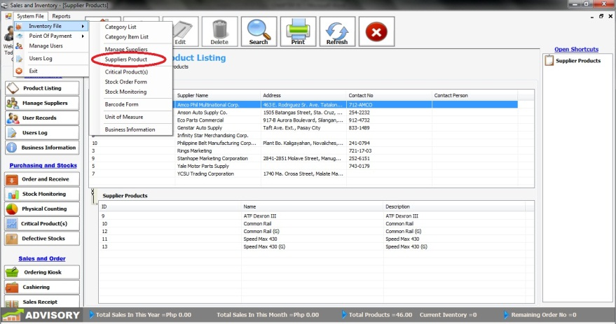

This is module can view all the suppliers and they’re products that they supply.

By clicking search button you can search a supplier by searching the supplier’s name.

By clicking print button you can choose whether you print by all suppliers’ product or selected supplier’s product.

8
9
USER RECORDS

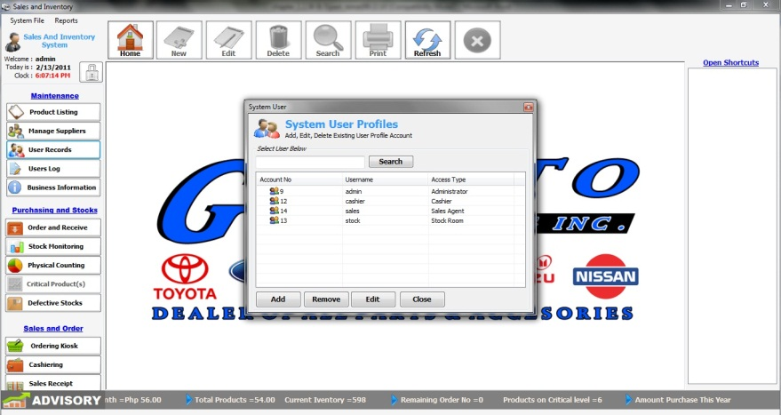
In this module, the admin can add, edit and remove users of the system.
- By clicking the add button the admin can add a new user from the system.
- By clicking the edit button the admin can edit a specific user and change the account type of the user.
- By clicking the remove button the admin can delete a record of a user from the system.

10
USERS LOG
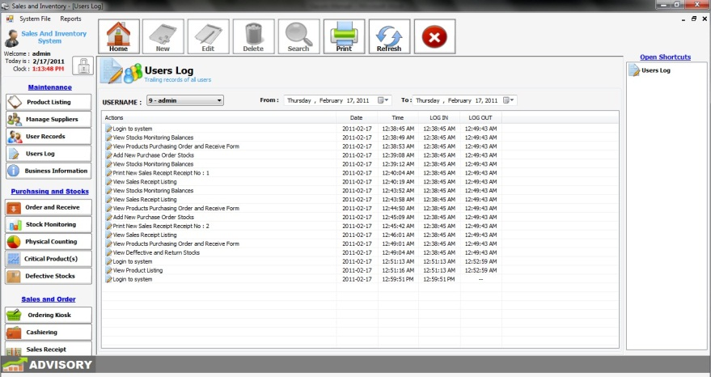
In this module, the admin can monitor all of the activities of the users.
- By clicking the drop down button the admin can choose to the list of users he/she wants to view.
- By clicking the print button the admin can print the activities of the user.
11

ORDER AND RECEIVE
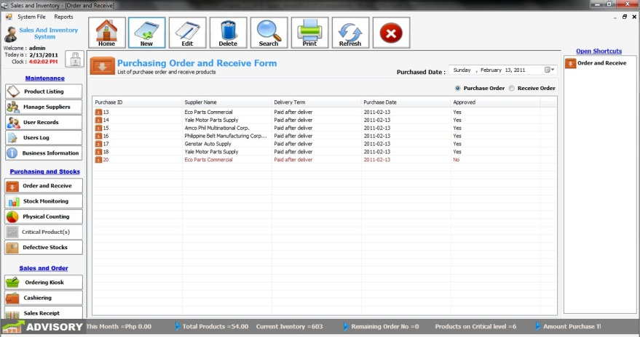
In this module, the user can create a Purchase Order form that can monitor the transactions between the company and the supplier.
In Purchase Order, the user can see all the pending order sends to the supplier; once the order is already approved and delivered the pending order will be automatically moved to the Received Order.
- By clicking the new button a purchase order form will appear and the user will fill out all the information needed in ordering an item.
- By clicking the print button the user can print all the information on Order and Receive.
12
13
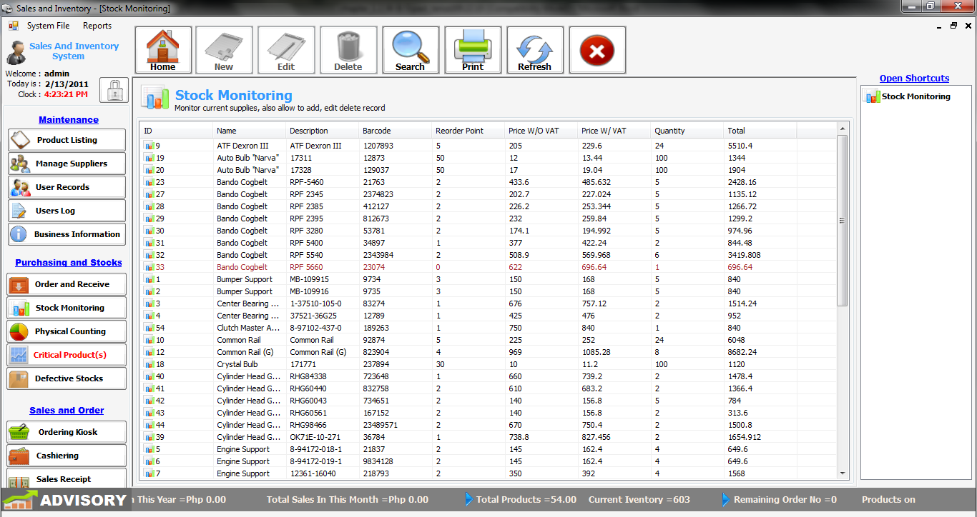
STOCK MONITORING
In this module, the user can see all the current stocks of the company. Including their ID, Product Name, Item Number, Brand, Description, Barcode, Reorder Point, Price W/O Vat, Price W/ Vat, Quantity, and Total.
- By clicking the search button the user can search the product by its product name.
- By clicking the print button the user can print all the current stocks in stock monitoring.

PHYSICAL COUNTING
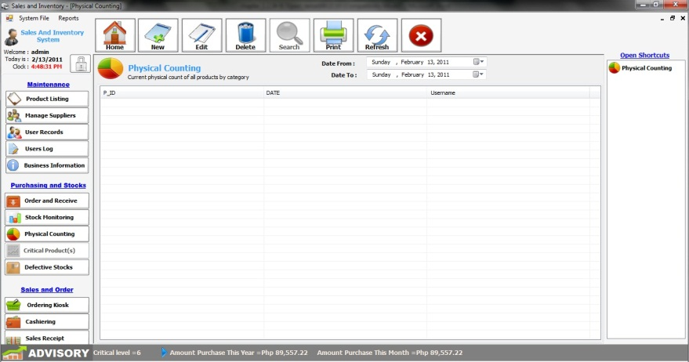
In this module, the users provide an automated process for performing a physical count.
- By clicking the new button the physical count form will appear. Just fill out the information and remarks will automatically appear if there is a missing item.
- By clicking the print button the user can print the report for physical counting.

14
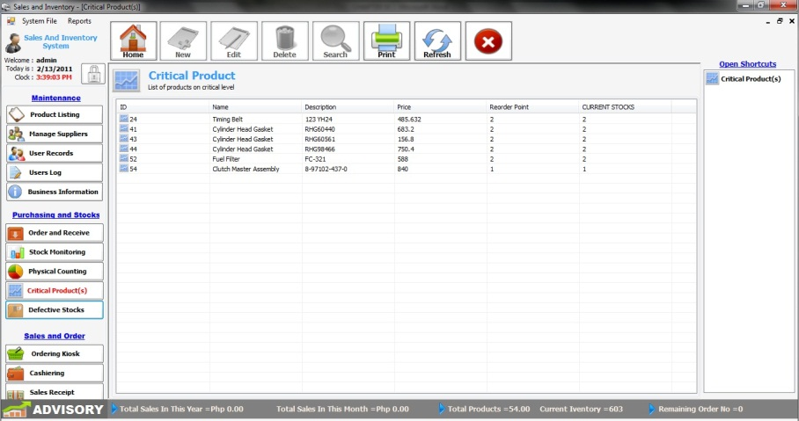
CRITICAL PRODUCT(S)
In this module, the user can see what product(s) that reaches the critical level.
- By double clicking the product the Purchase Order Form will appear.
- By clicking the print button the user can print the report for critical product(s).

15
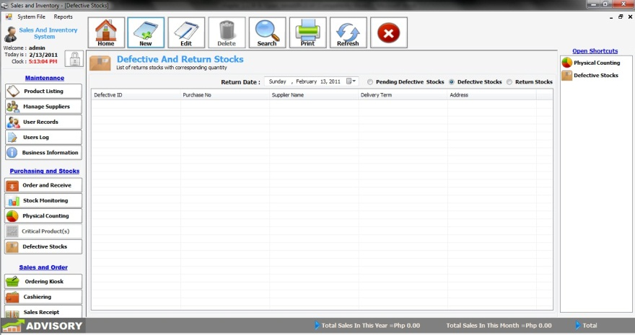
DEFECTIVE STOCKS

In this module, the user can’t see any product unless the user makes it as a defective product. In Defective Stocks, once the defective stock is returned from the supplier, it will automatically move in the Return Stocks.
- By clicking the new button in the Defective Stocks, a form will appear and choose the product you want to list as a defective.
- By clicking the print button the system will print a report that depends on what radio button you have clicked.

ORDERING KIOSK
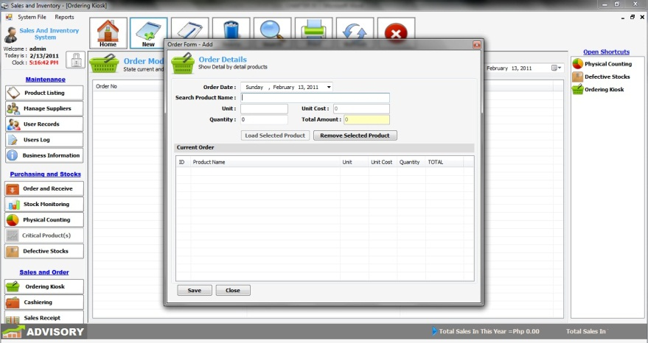

In this module, the user can search the product by its product name and enter the quantity desired by the customer and the system will automatically compute the amount of the product. After it is approved the system will automatically print a temporary order slip.
- By clicking the new button an order form will appear and the user must fill out the fields after the confirmation. A temporary order slip will be generated.
- By clicking the edit button the user can edit or change the product and quantity ordered by the customer.
16
17
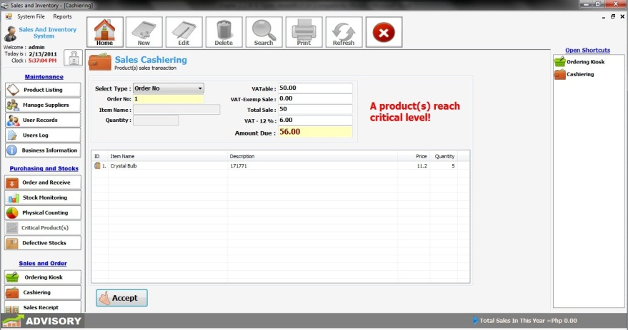
CASHIERING

This module is the POS (Point of Sales); this is where all the transactions between the cashier and customer will be done.
It also prompts the Cashier if a specific product(s) reaches it critical level.
- The user can select the type by clicking the drop down button. The user can enter the order by typing the order slip number or choose product barcode if the Cashier wants to use the barcode.
- When choosing Product Barcode, just simply aim the barcode reader at the barcode number and click the trigger button of the barcode.
- The form will show the VATable, VAT-exemp, Total Sale, VAT 12% and Amount Due at the right side of the module.
- Enter the quantity of the product that the customer would like to buy.
- If the user wants to delete an item, just click Delete in the keyboard.
- After the transaction just click 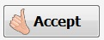 button then the system will automatically generate the official receipt.
18
19

SALES RECEIPT
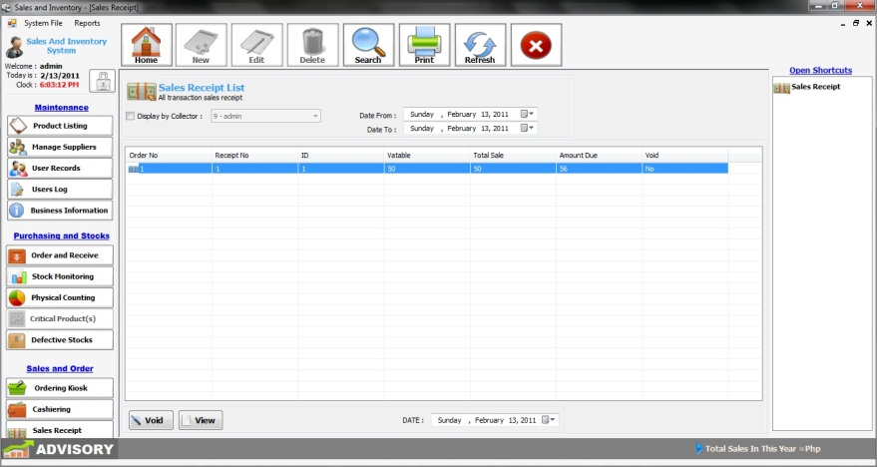
In this module, it shows all the successful transaction made by the Cashier. The user can view it by checking the check box and click the drop down button beside the Display by Collector.
The user can also view the transactions by adjusting the date in the upper right corner of the form.
If the user wants to void the transaction, just simply click the desired transaction then click the VOID button.
20
21
REPORTS
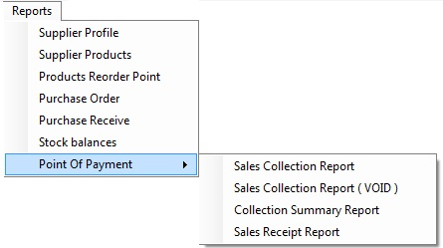
If the user wants to print a report, just click the reports at the upper portion of the screen. Then choose the report you want to print.

